Use Case Report



# **1. Use Case Diagram**

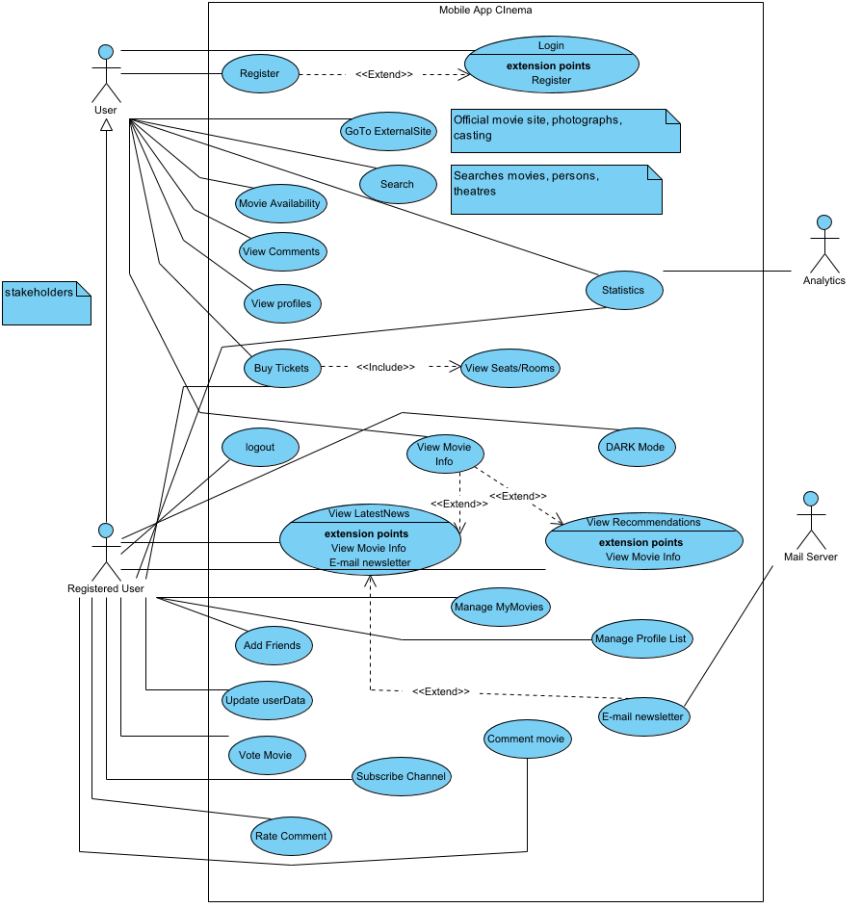

# **2. Prioritized Use Cases**

| **Name** | **Description** | **Priority** | **Size** | **Complexity** |
| --- | --- | --- | --- | --- |
| Manage Profile List | perfrom profile changes like picture change | Should | Small | Low |
| Login | Access premium services | Must | Medium | Low |
| GoTo ExternalSite | Look extra information sources | Could | Very Small | Low |
| View LatestNews | Top NewsFeeds of movie | Should | Medium | Medium |
| Add Friends | perform add requests | Must | Large | Medium |
| Buy Tickets | do reservations of ticket to nearby cinemas | Must | Large | High |
| View Comments | Look user comments | Should | Medium | Medium |
| Movie Availability | Perform lookup of available movies | Must | Large | High |
| View Seats/Rooms | View available seats | Must | Large | High |
| Search | perform Live Search to Services | Should | Medium | Medium |
| View Recommendations | Based on your movie/tv series most watch categories | Should | Large | Medium |
| View Movie Info | Movie information of the section | Should | Small | Low |
| View profiles | For register users only | Must | Medium | Low |
| Comment movie | Registered users Only | Should | Medium | Medium |
| E-mail newsletter | For Registered users only. News about updates of site changes and Services.(movies included) | Should | Large | Medium |
| Rate Comment | Registered users only | Should | Small | Low |
| DARK Mode | For the Night Owls | Must | Very Small | Low |
| Register | Authentication System | Must | Large | Medium |
| Statistics | Gather User Statistics Bounce Rate mobile Devices, Region etc | Could | Medium | Medium |
| Update userData | CRUD operations on user information | Must | Small | Low |
| Subscribe Channel | to Channel Pages 1 user can have 1 page and upload movies after getting verified by the organization CineSocial like netflix + youtube approach more fluent | Should | Medium | Medium |
| Vote Movie | Vote for movie if its bad or good | Should | Medium | Low |
| logout | Logout registered user from services | Must | Very Small | Low |
| Manage MyMovies | MyList of movies/tv series | Should | Medium | Medium |
| Evaluate Software Product |  |  |  |  |
| Define Software Deliverables |  |  |  |  |
| Identify Software Components |  |  |  |  |
| Plan Software Production |  |  |  |  |
| Evaluate Software Components |  |  |  |  |
| Identify Software Requirements |  |  |  |  |